BEST and WORST surgeries in the Basildon area - as ranked by patients
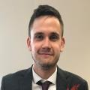
By Robbie Bryson robbiebryson1Reporter
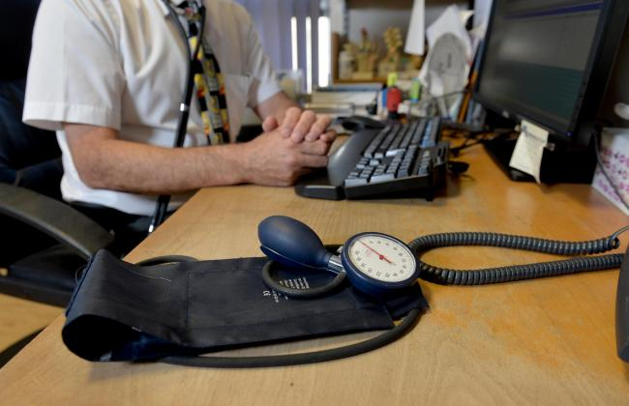
GP stock image
2 comments
THE best doctor's surgeries across Basildon have been ranked according to patients.
All of the GPs overseen by the Basildon and Brentwood Clinical Commissioning Group have been ranked in the 2020 NHS patient survey.
The survey data is collated by asking patients their views on their experiences at the surgeries.
Which are the best surgeries in the area?
The top rated surgery in Basildon was Dr T Nasah& Partners, at the Dipple Medical Centre, in Wickford Avenue.
The surgery received the highest overall experience rating in the town, with 87 per cent of respondents saying the surgery was "good".
Four surgeries received higher ratings - The Highwood Surgery, in Brentwood, Western Road Surgery, in Billericay, Mount Avenue Surgery in Brentwood and Chapel Street Surgery in Billericay.
The average rating amongst surgeries in the Basildon and Brentwood Clinical Commissioning Group is 77 per cent.
What about the worst surgeries?
The worst rated surgery for overall experience was Dr Aslam's Practice, in Rectory Road, Basildon, where 55 per cent of patients said the service was "good".
Dr Sharma and Partners, in Bridge Street, Basildon, was second bottom, with 59 per cent rating it as "good".
How did all the surgeries do?
Full list of surgeries in the CCG:
- The Highwood Surgery - 99%
- Western Road Surgery - 92%
- Mount Avenue Surgery - 91%
- Chapel Street Surgery - 90%
- Dr Nasah and Partners - 87%
- Queens Park Surgery - 85%
- Rockleigh Court Surgery - 85%
- South Green Surgery - 83%
- The New Folly Surgery - 83%
- Dr N Dabas's Practice - 83%
- Dr Salako and Partners - 82%
- The Billericay Medical Practice - 82%
- The House Surgery - 82%
- Aryan Medical Centre - 81%
- Deal Tree Health Centre - 81%
- Rose Villa Surgery - 80%
- Laindon Medical Group - 80%
- Dr Degun and Dr Macauley - 79%
- London Road Surgery - 77%
- Dr Jo Arayomi's Practice - 76%
- Matching Green Surgery - 74%
- Fryers Medical Centre - 74%
- Dr GC Chaied's Practice - 74%
- Dr Sims and Partners - 72%
- Swanwood Partnership - 72%
- Felmore Medical Centre - 72%
- Robert Frew Medical Centre - 72%
- Dr A Naem and Partners The New Surgery - 71%
- Beechwood Surgery - 71%
- Knights Surgery - 70%
- Clayhill Medical Practice - 66%
- Aegis Medical Centre - 62%
- Ballards Walk Surgery - 60%
- Dr Sharma and Partners - 59%
- Dr M Aslam's Practice - 55%

